**Sri Lanka Institute of Information technology 2022**

**SYSTEMS AND NETWORK PROGRAMMING- SNP**

**Lab sheet 02**

**Year 2, Semester 1**

IT21171260

L.H.M.J.C.Lansakara

Y2.S1.WD.CS.02.G01

MALABE CAMPUS

The password is Natas0

UserName : natas0

Password : natas0

The password is Natas1

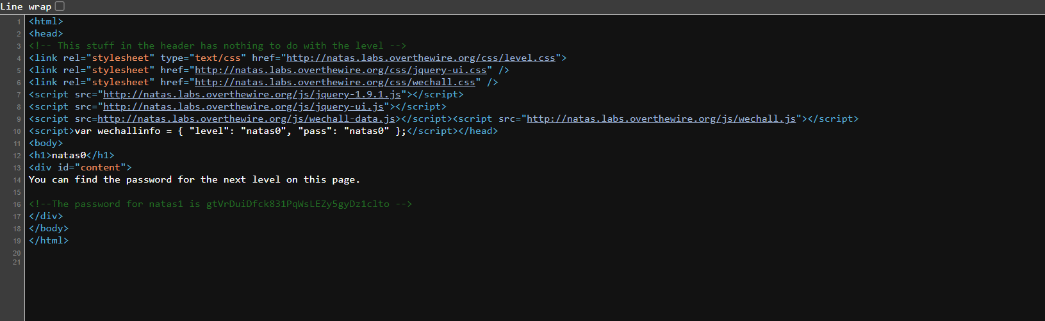

The password id Natas 2

The Password is Natas 3

Natas 4

Natas 5

Natas 6

Natas 7

Natas 8

Natas 9

